SIMATS ENGINEERING
ASSESSMENT TOOL 1

COURSE NAME:Database Management Systems
COURSE CODE: CSA05

COURSE OUTCOME COVERED
CO3: Analyze relational databases using functional dependencies, normalization (1NF to 5NF), and key constraints to identify redundancy and ensure data integrity. (BL2, BL3)
Activity Tool : Experiments (High)
Assessment Tool Weightage: 40%

QUESTIONS Total Marks: 50
Q.No | Question | Bloom's Level | Marks
1 | For the relation STUDENT_COURSE(SID, SName, CID, CName, Instructor, Grade), identify all functional dependencies and determine the candidate keys. | BL2 – Understand | 5
2 | Demonstrate the process of converting an unnormalized relation into 1NF with step-by-step justification and example. | BL3 – Apply | 5
3 | Given relation R(A,B,C,D,E) with FDs: A→BC, BC→D, D→E. Analyze and decompose it to 2NF eliminating partial dependencies. | BL3 – Apply | 5
4 | Apply 3NF decomposition on the relation EMPLOYEE(EmpID, EmpName, DeptID, DeptName, ManagerID) with transitive dependencies. | BL3 – Apply | 5
5 | Verify whether R(A,B,C,D) with FDs: AB→C, C→D, D→A is in BCNF. If not, decompose it into BCNF. | BL3 – Apply | 5
6 | Experimentally verify lossless-join decomposition for a given relation using the tabular (Chase) algorithm. | BL3 – Apply | 5
7 | Identify the multi-valued dependencies in TEACHER(TID, Subject, Hobby) and decompose it into 4NF. | BL3 – Apply | 5
8 | Demonstrate how join dependencies lead to redundancy. Decompose a given relation to 5NF (Project-Join Normal Form). | BL3 – Apply | 5
9 | Given a poorly designed database schema for a college, identify all anomalies (insertion, deletion, update) and normalize it to 3NF. | BL2 – Understand | 5
10 | Compute the closure of attribute sets for the given FDs and determine all candidate keys for the relation. | BL3 – Apply | 5
Code of Conduct:

I THARUN KUMAR-192571017 certify that this submission is my original work and that I have adhered to the guidelines specified for this assessment.
I understand that any violation of academic integrity rules will result in disciplinary action.
Signature of the student:

RUBRICS FOR CALCULATION:

Criteria | Level 4 – Exemplary | Level 3 – Proficient | Level 2 – Developing | Level 1 – Beginning
Understanding of Concepts | Demonstrates thorough understanding and effectively integrates multiple concepts/technologies | Good understanding with proper integration of most concepts | Basic understanding; limited or partial integration | Poor understanding; unable to integrate concepts
Experimental Design | Well-planned, systematic implementation with optimal solution | Correct implementation with minor issues | Basic implementation with errors or inefficiencies | Incorrect or incomplete implementation
Use of Tools | Effective and advanced use of tools/technologies with proper configuration | Appropriate use of tools with correct execution | Limited or inconsistent use of tools | Incorrect or minimal use of tools
Analysis of Results | Insightful analysis with accurate interpretation and validation of results | Good analysis with reasonable interpretation | Basic analysis with limited insights | Poor or incorrect analysis of results
Documentation | Clear, well-structured documentation with diagrams, code, and results | Organized documentation with necessary details | Basic documentation with missing details | Poor or incomplete documentation
Q1. STUDENT_COURSE – Functional Dependencies and Candidate Keys
Given Relation
STUDENT_COURSE(SID, SName, CID, CName, Instructor, Grade)
Assume that:
- Each student has a unique SID.
- Each course has a unique CID.
- A student can enroll in many courses.
- A course can have many students.
- Grade is specific to a particular student in a particular course.
Functional Dependencies
The functional dependencies are:
- SID → SName
A student's ID uniquely determines the student's name.
- CID → CName
A course ID uniquely determines the course name.
- CID → Instructor
A course ID determines its instructor.
- (SID, CID) → Grade
The combination of student ID and course ID determines the grade obtained by that student.
Therefore, the main set of FDs is:
F = { SID → SName, CID → CName, CID → Instructor, SID,CID → Grade }
Finding Candidate Key
Consider:
(SID, CID)+
Starting with:
{SID, CID}
Using SID → SName:
{SID, CID, SName}
Using CID → CName and CID → Instructor:
{SID, CID, SName, CName, Instructor}
Using (SID,CID) → Grade:
{SID, CID, SName, CName, Instructor, Grade}
Therefore:
(SID, CID)+ = {SID, SName, CID, CName, Instructor, Grade}
Since the closure contains all attributes, (SID, CID) is a superkey.
Neither SID nor CID alone can determine all attributes.
Therefore, the candidate key is:
Candidate Key = {SID, CID}
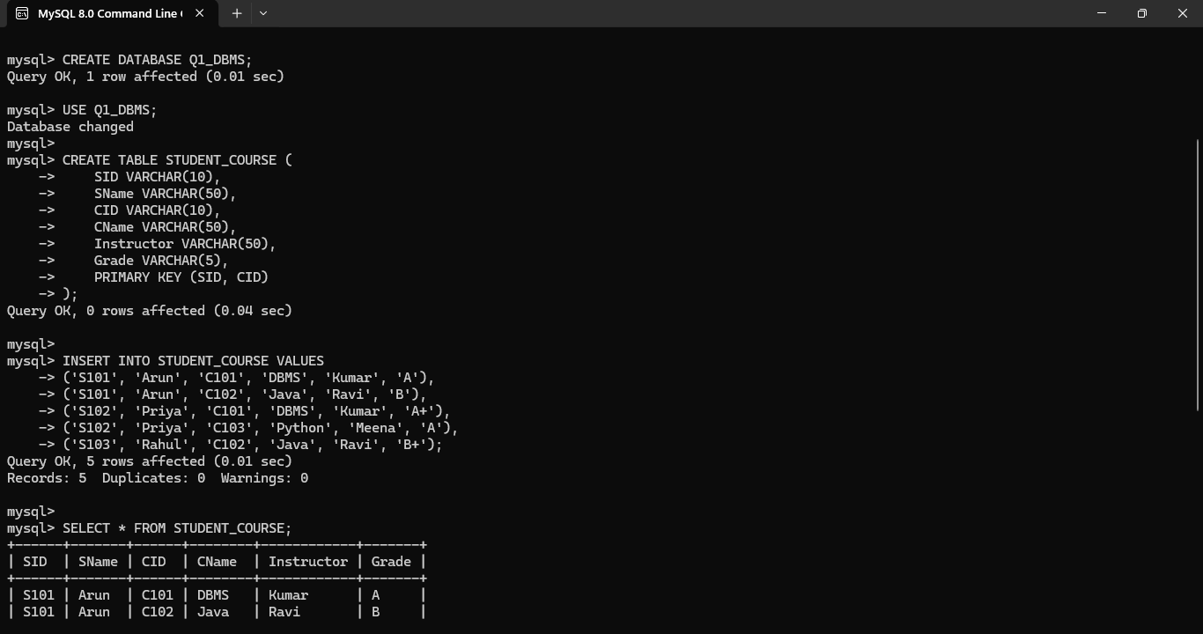
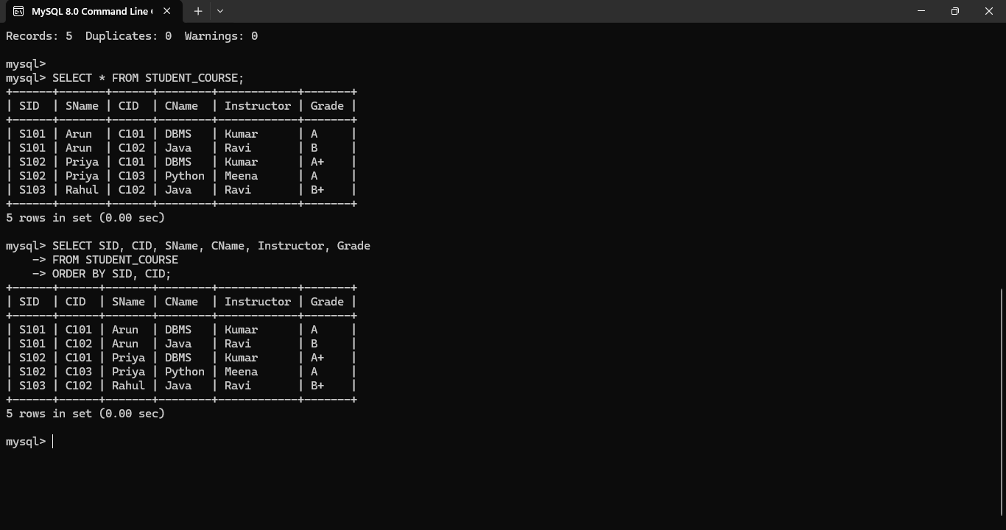

Result
The relation has functional dependencies involving student and course information, and its candidate key is (SID, CID). The relation contains redundancy because student and course information may be repeated for every enrollment.

Q2. Conversion of an Unnormalized Relation into 1NF
Aim
To demonstrate the conversion of an unnormalized relation into First Normal Form (1NF).
Unnormalized Relation
Consider the following STUDENT relation:
SID | SName | Courses
S101 | Arun | DBMS, Java, Python
S102 | Ravi | DBMS, C++
Here, the Courses attribute contains multiple values in a single cell.
This violates the requirement of 1NF because every attribute must contain a single atomic value.
Step 1 – Identify the Repeating Group
For student S101:
Courses = DBMS, Java, Python
There are three values in one attribute.
For student S102:
Courses = DBMS, C++
There are two values in one attribute.
Therefore, the relation is not in 1NF.
Step 2 – Remove Repeating Groups
Each course is represented as a separate row.
1NF Relation
SID | SName | Course
S101 | Arun | DBMS
S101 | Arun | Java
S101 | Arun | Python
S102 | Ravi | DBMS
S102 | Ravi | C++
Now every cell contains exactly one value.
Step 3 – Determine Key
A student can take multiple courses, so SID alone is not sufficient.
The combination:
(SID, Course)
uniquely identifies each record.
Therefore:
Candidate Key = (SID, Course)
Justification
The relation is now in 1NF because:
- All attributes contain atomic values.
- There are no repeating groups.
- Each row represents one student-course combination.
- The composite key uniquely identifies each record.

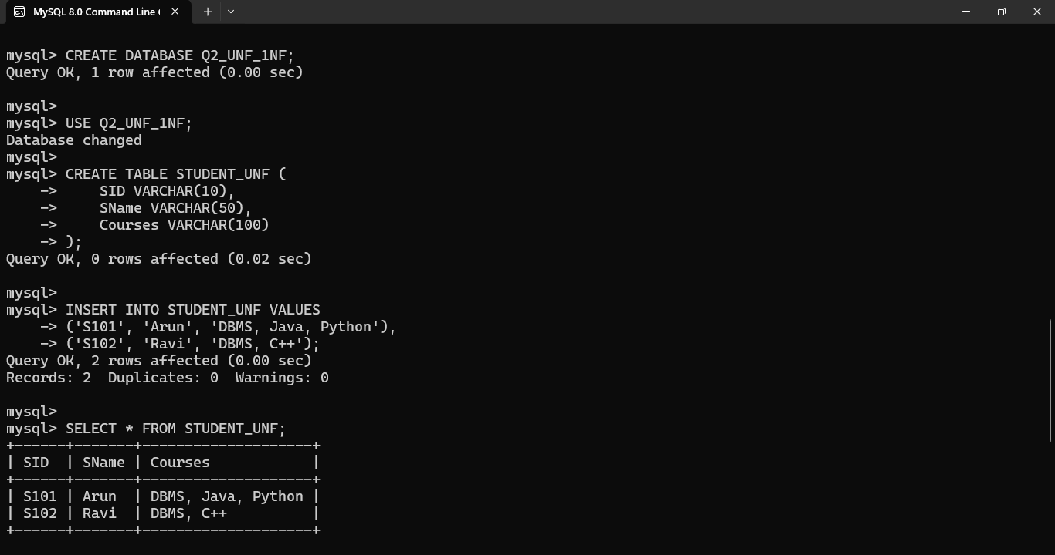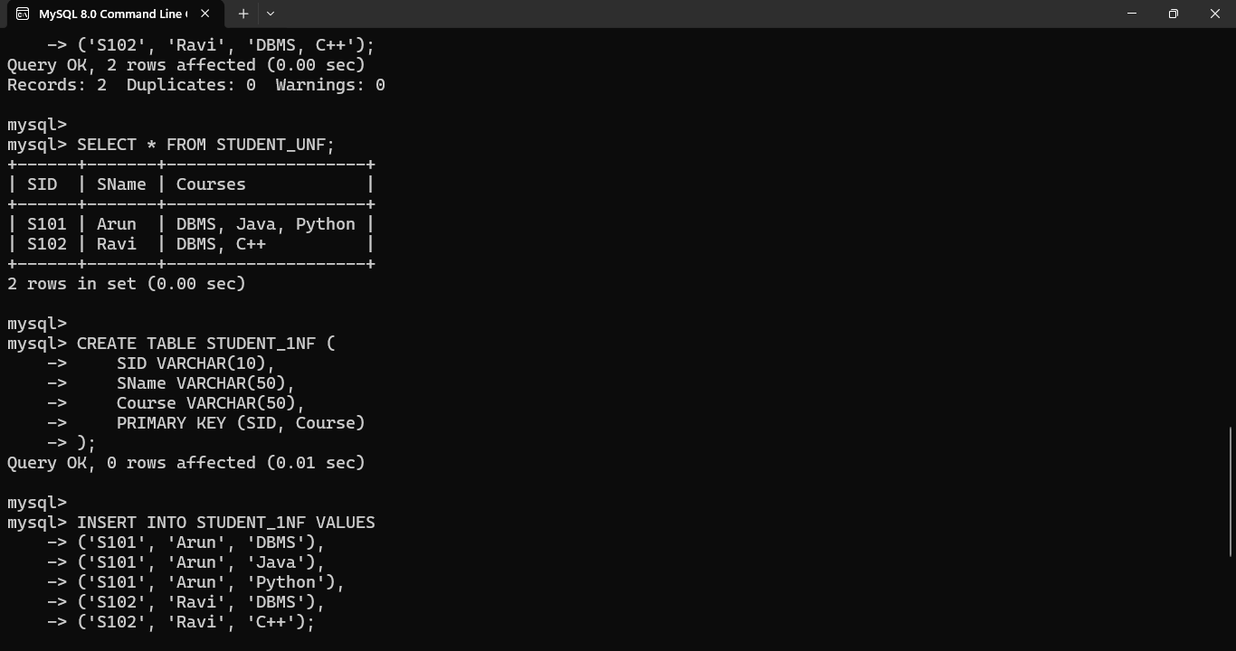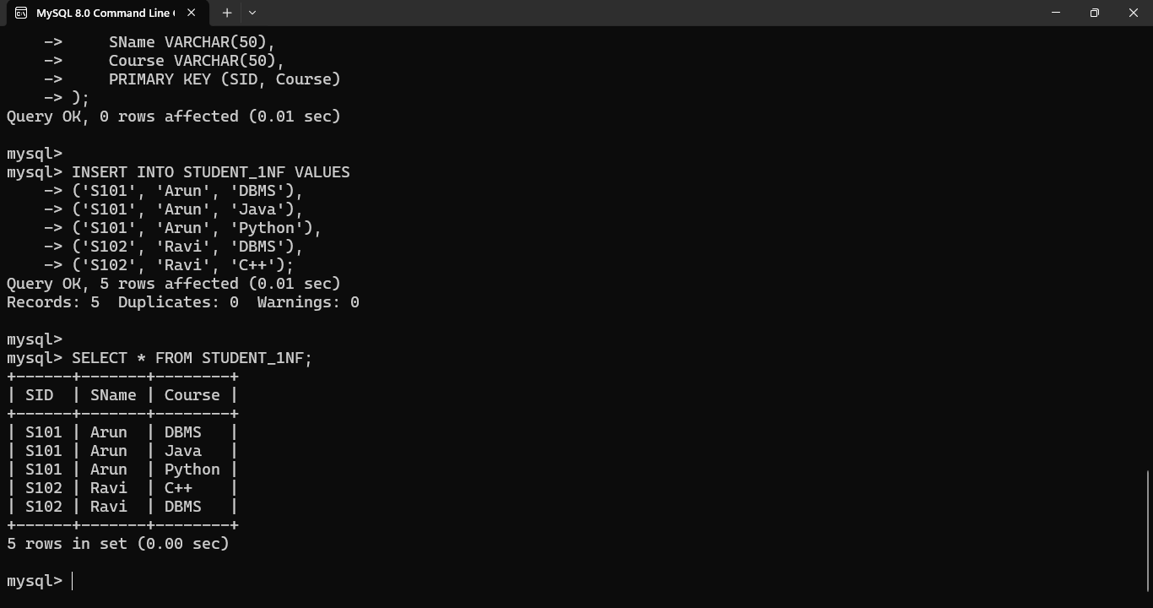
Result
The unnormalized relation has been successfully converted into 1NF by removing repeating groups and ensuring atomic values.

Q3. Decomposition of R(A,B,C,D,E) into 2NF
Given
Relation:
R(A, B, C, D, E)
Functional Dependencies:
- A → BC
- BC → D
- D → E
Step 1 – Find Candidate Key
Calculate A+.
Initially:
A+ = {A}
Using:
A → BC
we get:
A+ = {A, B, C}
Using:
BC → D
we get:
A+ = {A, B, C, D}
Using:
D → E
we get:
A+ = {A, B, C, D, E}
Therefore:
A+ = {A,B,C,D,E}
Hence, A is a candidate key.
Step 2 – Check Partial Dependencies
2NF requires:
- The relation must be in 1NF.
- No non-prime attribute should depend on a proper subset of a composite candidate key.
Here the candidate key is a single attribute A.
Therefore, a partial dependency cannot exist because there is no proper subset of A.
Hence, the relation is already in 2NF.
Step 3 – Important Observation
Although the relation is in 2NF, it is not in 3NF because:
A → BC
BC → D
D → E
There are transitive dependencies.
For example:
A → D → E
Therefore, further decomposition is required for 3NF.
2NF Result
The relation remains:
R(A, B, C, D, E)
because there are no partial dependencies.
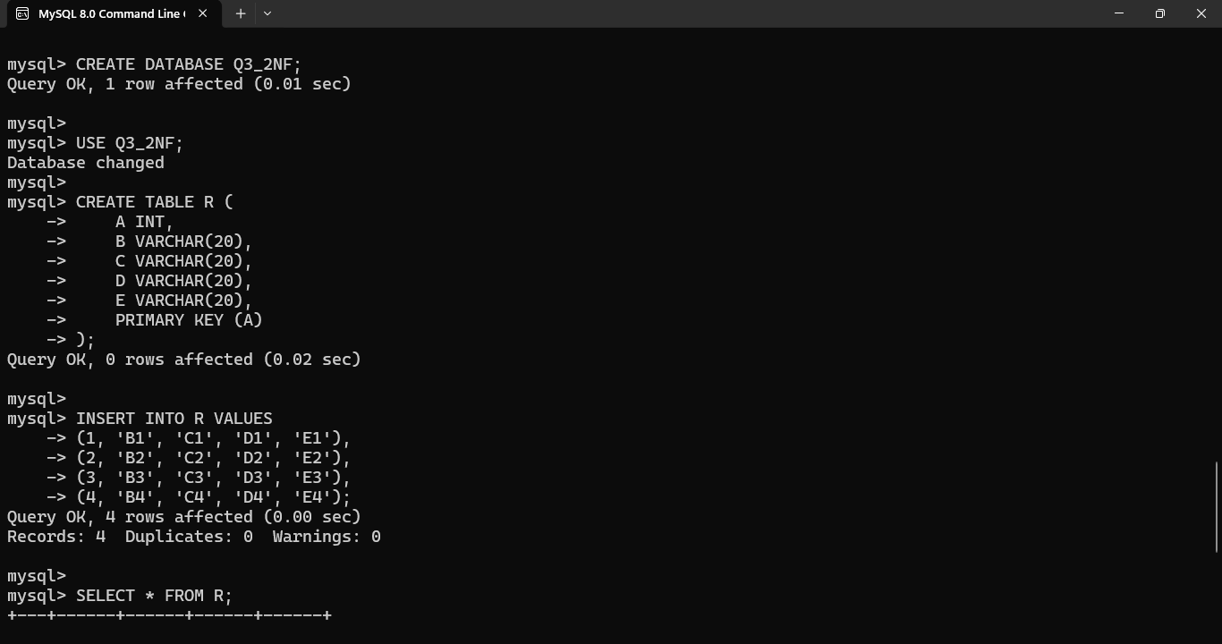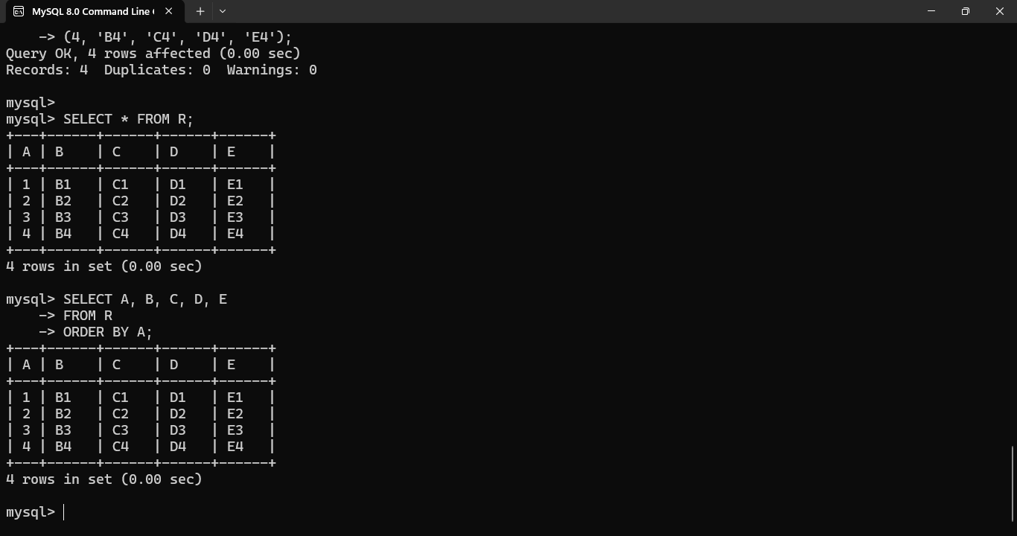

Result
The relation R(A,B,C,D,E) is already in 2NF since its candidate key is the single attribute A, so partial dependency is not possible. However, it requires further decomposition to achieve 3NF.

Q4. 3NF Decomposition of EMPLOYEE
Given Relation
EMPLOYEE(EmpID, EmpName, DeptID, DeptName, ManagerID)
Assume the following functional dependencies:
- EmpID → EmpName, DeptID
- DeptID → DeptName, ManagerID
Step 1 – Find Candidate Key
EmpID uniquely identifies an employee.
Therefore:
EmpID → EmpName, DeptID
Then:
DeptID → DeptName, ManagerID
So:
EmpID → DeptID → DeptName, ManagerID
Thus:
EmpID+ = {EmpID, EmpName, DeptID, DeptName, ManagerID}
Therefore:
Candidate Key = EmpID
Step 2 – Identify Transitive Dependency
We have:
EmpID → DeptID
and:
DeptID → DeptName, ManagerID
Therefore:
EmpID → DeptName, ManagerID
through DeptID.
This is a transitive dependency.
Step 3 – Decompose
Create two relations.
Relation 1 – EMPLOYEE
EMPLOYEE(EmpID, EmpName, DeptID)
EmpID | EmpName | DeptID
E101 | Arun | D01
E102 | Ravi | D02
E103 | Kumar | D01
Primary Key: EmpID
Relation 2 – DEPARTMENT
DEPARTMENT(DeptID, DeptName, ManagerID)
DeptID | DeptName | ManagerID
D01 | Computer Science | M01
D02 | Electronics | M02
Primary Key: DeptID
Foreign Key
In EMPLOYEE:
DeptID references DEPARTMENT(DeptID)

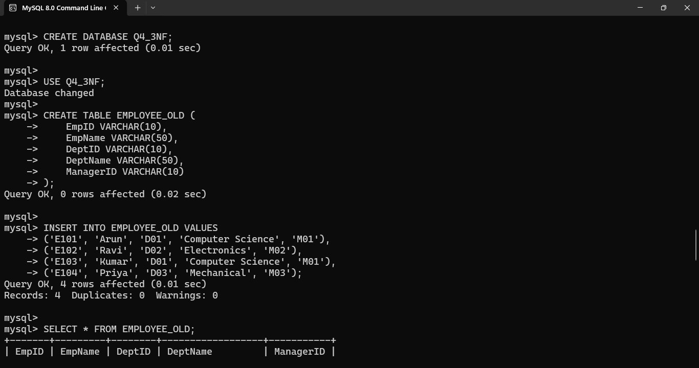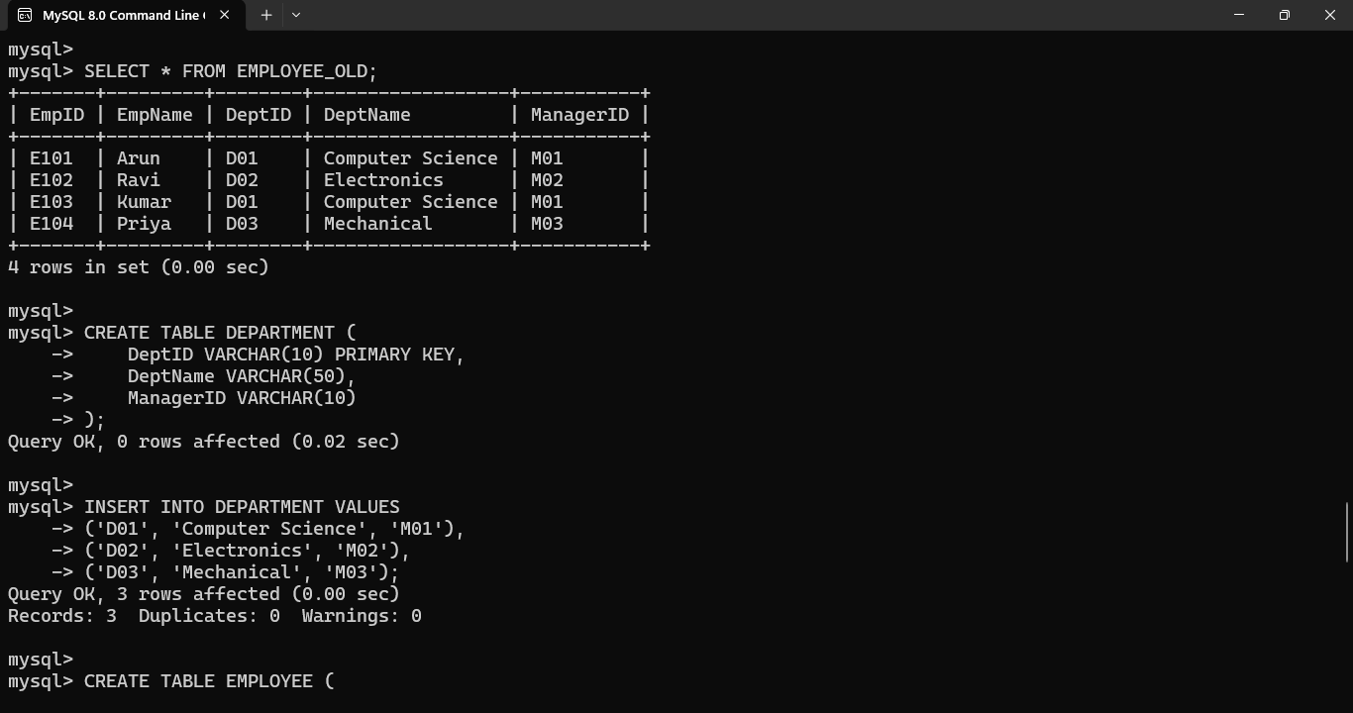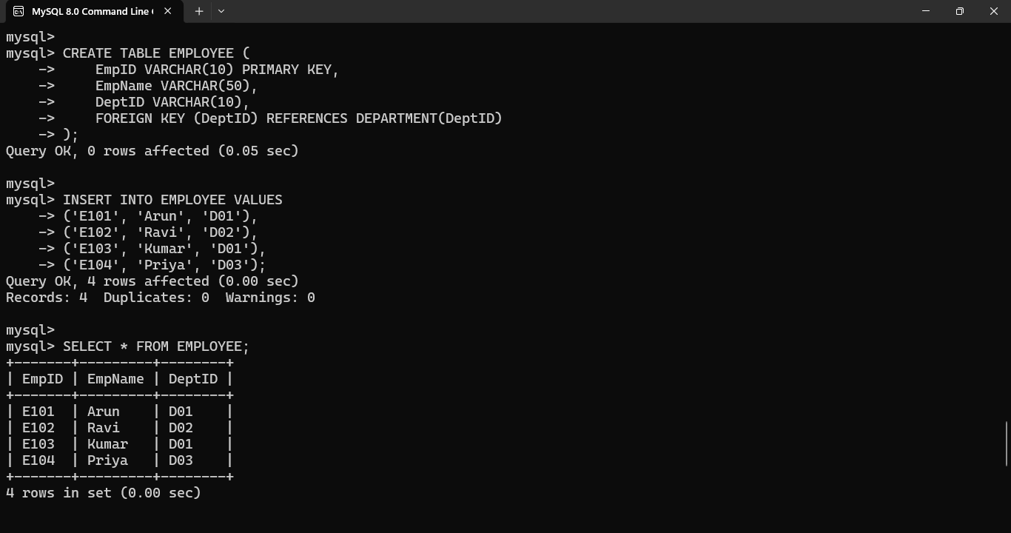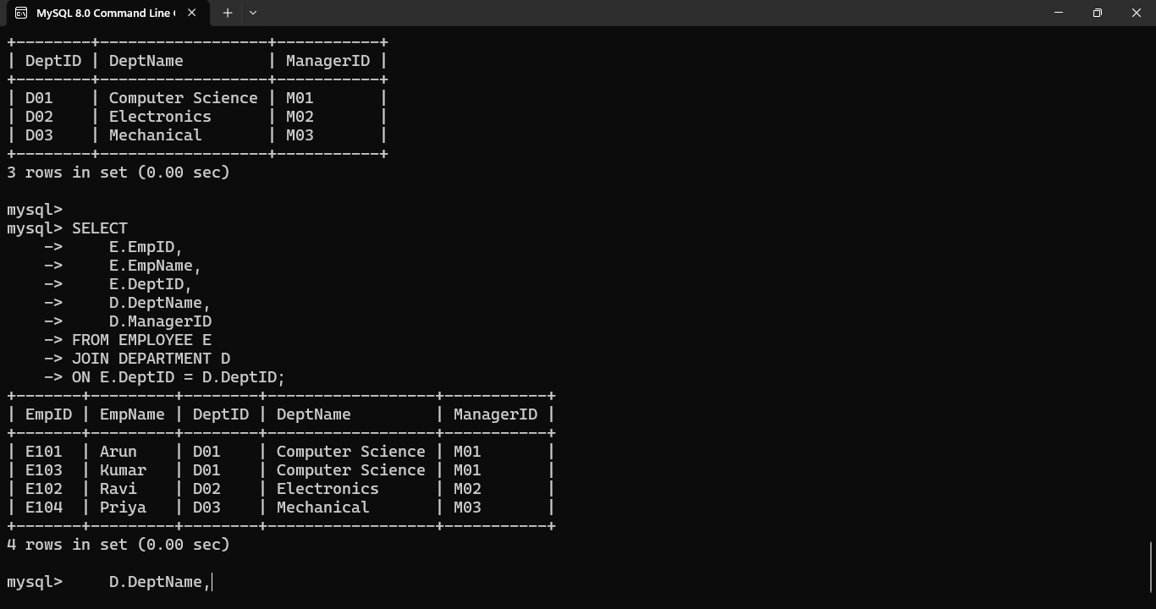
Result
The original relation has been decomposed into:
EMPLOYEE(EmpID, EmpName, DeptID)
DEPARTMENT(DeptID, DeptName, ManagerID)
The transitive dependency has been removed, reducing redundancy and update anomalies.
Q5. BCNF Verification and Decomposition
Given Relation
R(A, B, C, D)
Functional Dependencies:
- AB → C
- C → D
- D → A
Step 1 – Find Candidate Keys
AB+
Start with:
AB+ = {A,B}
Using:
AB → C
we get:
{A,B,C}
Using:
C → D
we get:
{A,B,C,D}
Therefore:
AB is a candidate key.

BC+
Start:
BC+ = {B,C}
Using:
C → D
we get:
{B,C,D}
Using:
D → A
we get:
{A,B,C,D}
Therefore:
BC is a candidate key.

BD+
Start:
BD+ = {B,D}
Using:
D → A
we get:
{A,B,D}
Using:
AB → C
we get:
{A,B,C,D}
Therefore:
BD is a candidate key.
Candidate Keys
AB, BC, BD
Step 2 – Check BCNF
A relation is in BCNF if for every non-trivial FD:
X → Y
X must be a superkey.
Check:
AB → C
AB is a candidate key, so it satisfies BCNF.
C → D
C is not a superkey because:
C+ = {C,D,A}
B cannot be obtained.
Therefore, C is not a superkey.
Hence, the relation violates BCNF.
Step 3 – Decompose
Using:
C → D
Create:
R1(C,D)
and:
R2(A,B,C)
Check R1
In R1:
C → D
C is the key of R1.
Therefore, R1 is in BCNF.
Check R2
R2 contains:
A, B, C
The dependency:
AB → C
exists, and AB is a key.
Thus R2 is in BCNF.
Final BCNF Decomposition
R1(C,D)
R2(A,B,C)
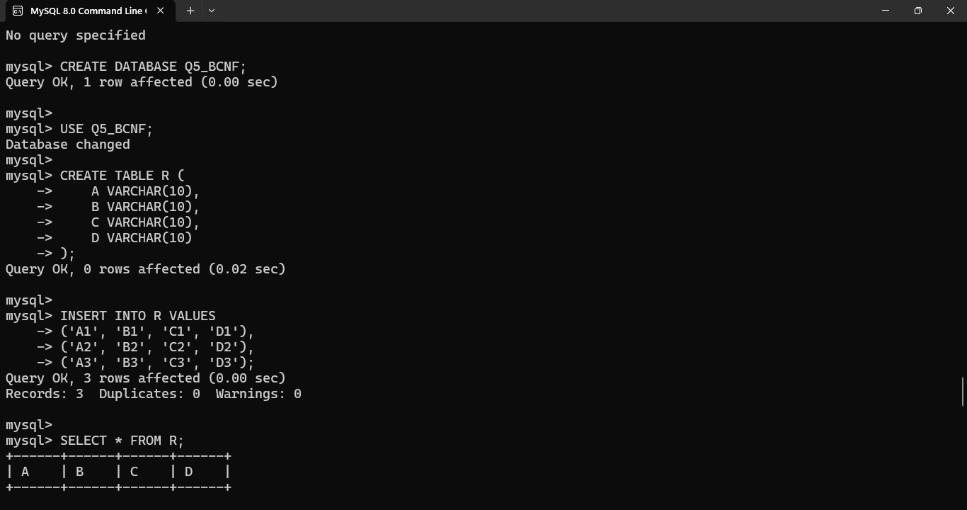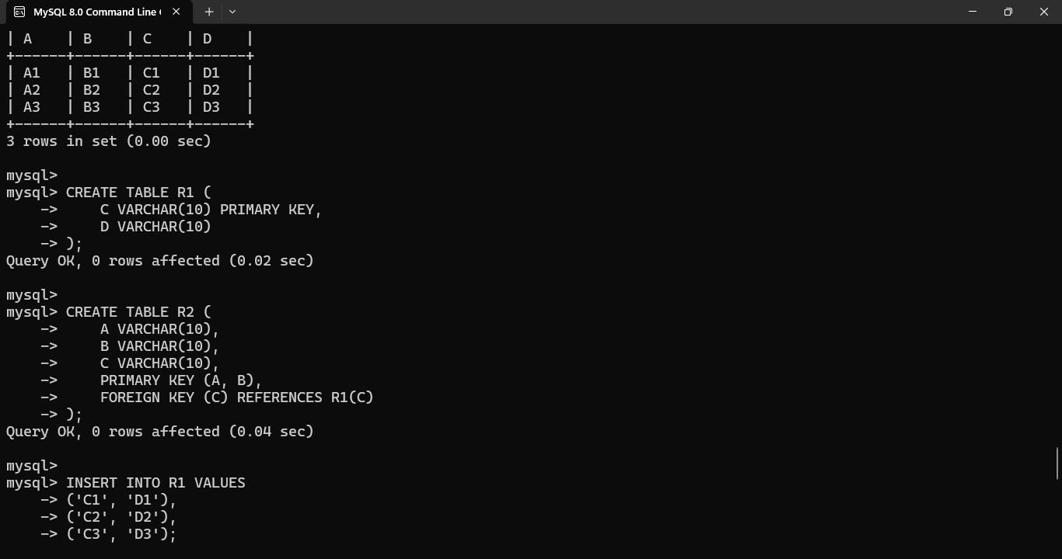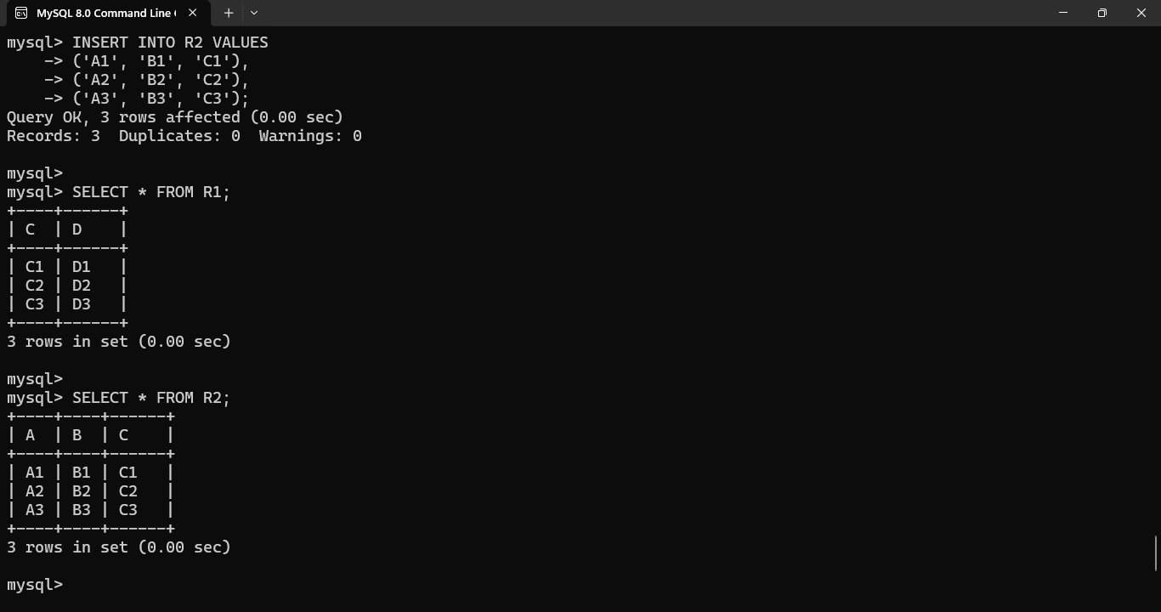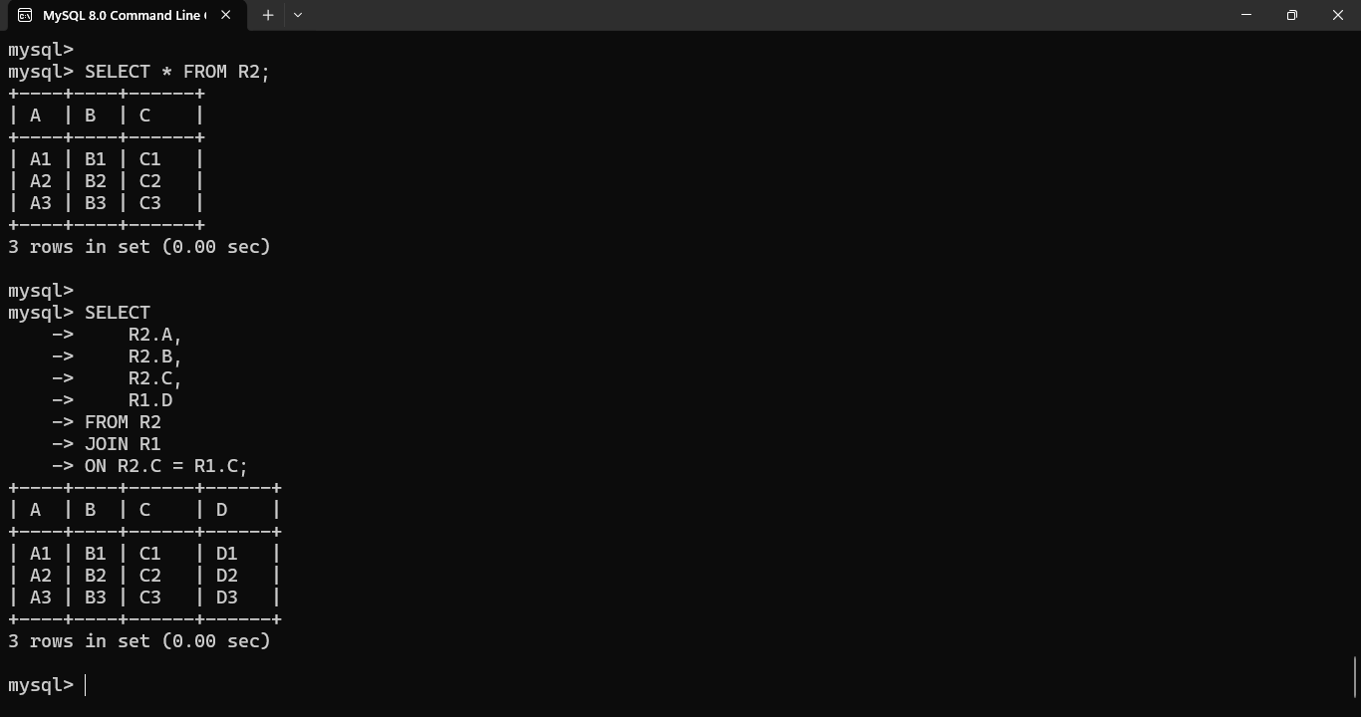
Result
The original relation is not in BCNF because C → D violates the BCNF condition. The BCNF decomposition is:
R1(C,D) and R2(A,B,C).

Q6. Lossless-Join Decomposition Using Chase Algorithm
Aim
To experimentally verify whether a decomposition is lossless using the Chase algorithm.
Given Relation
Consider:
R(A, B, C)
with functional dependency:
A → B
Decompose R into:
R1(A,B)
R2(A,C)
We need to determine whether the decomposition is lossless.
Step 1 – Create Initial Tableau
Row | A | B | C
R1 | a | b | c1
R2 | a | b2 | c
Here:
- Common attribute between R1 and R2 is A.
- The value of A is made the same in both rows.
Step 2 – Apply FD
Given:
A → B
Both rows have the same value for A.
Therefore, their B values must become the same.
The common distinguished value for B is propagated.
Row | A | B | C
R1 | a | b | c1
R2 | a | b | c
Step 3 – Check for Distinguished Row
The second row now contains:
a, b, c
All attributes contain the distinguished symbols.
Therefore, the decomposition is lossless.
Explanation
When the decomposition is joined:
R1(A,B) ⋈ R2(A,C)
we obtain:
A | B | C
a | b | c
which is exactly the original relation.
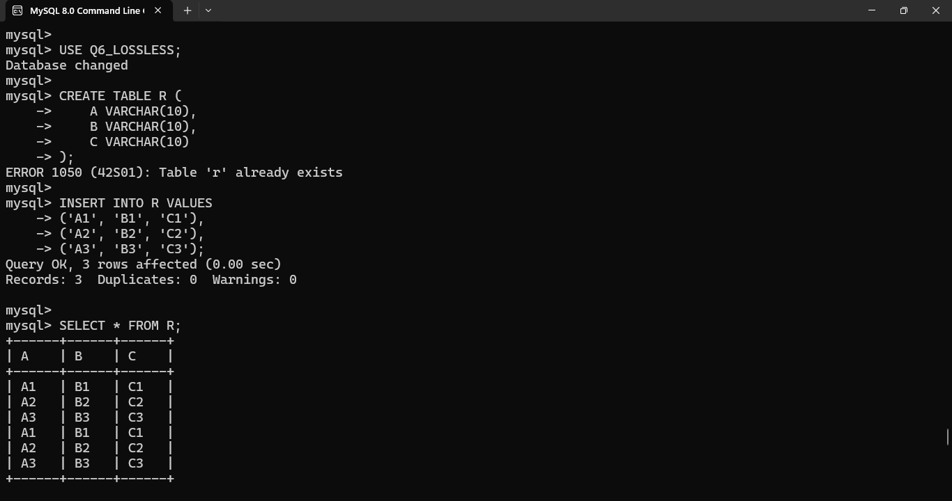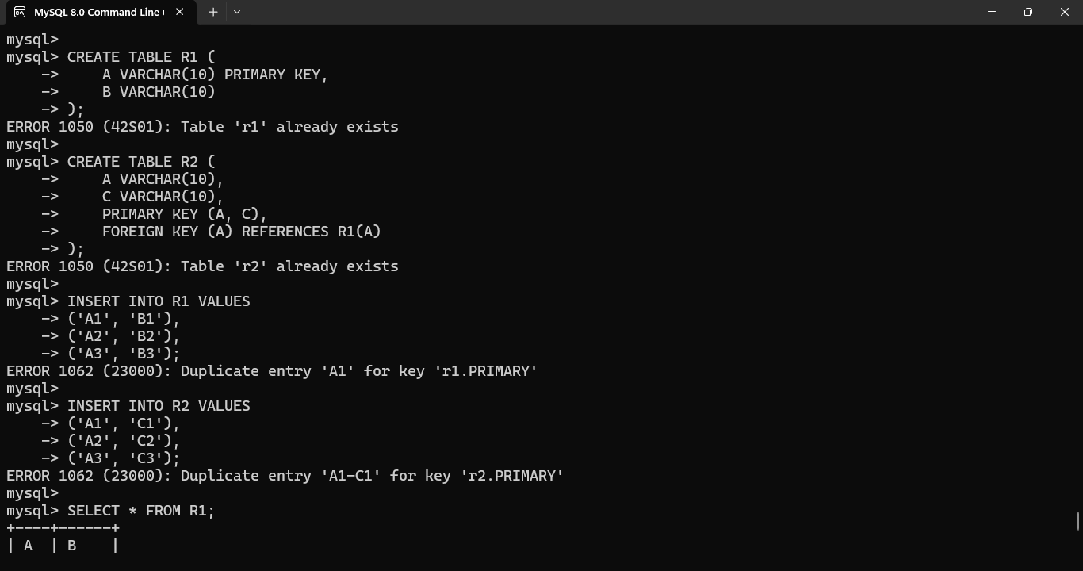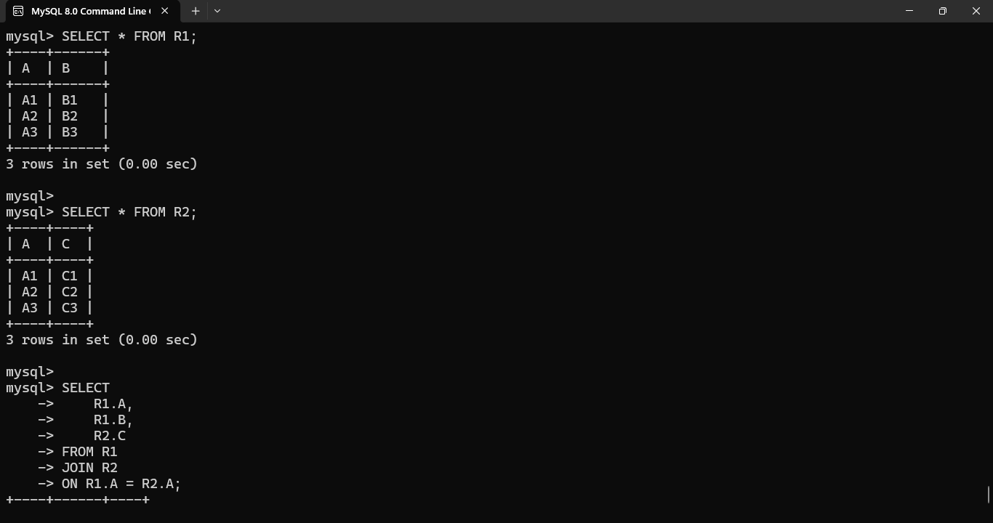
Result
Since the Chase algorithm produces a row containing all distinguished attributes, the decomposition:
R → R1(A,B), R2(A,C)
is lossless-join.

Q7. Multivalued Dependencies and 4NF
Given Relation
TEACHER(TID, Subject, Hobby)
Assume a teacher can teach multiple subjects and have multiple hobbies, and these two sets are independent.
For example:
TID | Subject | Hobby
T01 | DBMS | Cricket
T01 | DBMS | Music
T01 | Java | Cricket
T01 | Java | Music
Step 1 – Identify Multivalued Dependencies
The subjects of a teacher are independent of the hobbies of that teacher.
Therefore:
TID →→ Subject
and:
TID →→ Hobby
These are multivalued dependencies.
Why Redundancy Occurs
Suppose teacher T01 teaches:
- DBMS
- Java
and has hobbies:
- Cricket
- Music
All combinations must be stored.
This causes unnecessary repetition.
Step 2 – Check 4NF
A relation is in 4NF if for every non-trivial multivalued dependency:
X →→ Y
X must be a superkey.
Here:
TID →→ Subject
But TID alone does not determine a unique complete tuple because a teacher can have multiple subjects and hobbies.
Therefore, the relation violates 4NF.
Step 3 – Decompose
Create two relations:
TEACHER_SUBJECT
TEACHER_SUBJECT(TID, Subject)
TID | Subject
T01 | DBMS
T01 | Java
TEACHER_HOBBY
TEACHER_HOBBY(TID, Hobby)
TID | Hobby
T01 | Cricket
T01 | Music
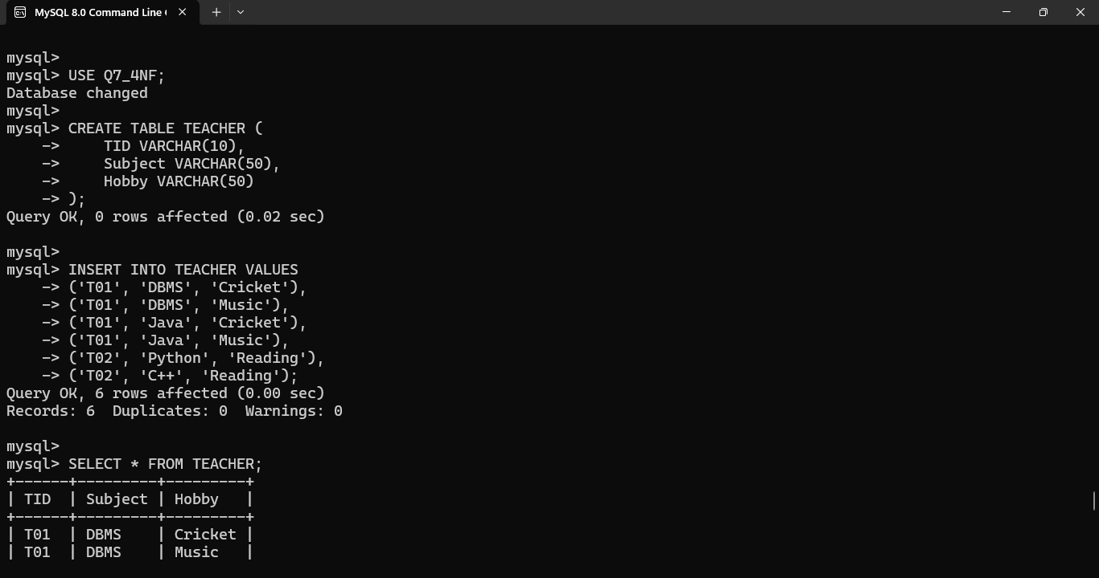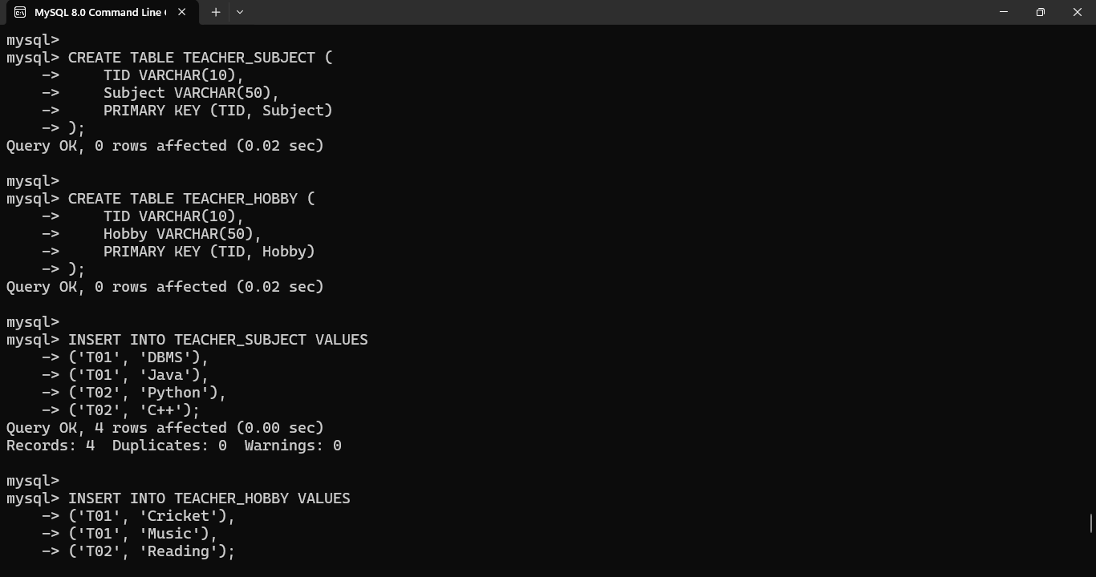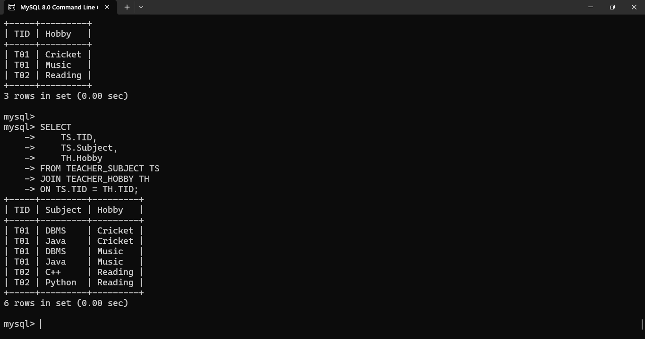
Result
The original relation is decomposed into:
TEACHER_SUBJECT(TID, Subject)
TEACHER_HOBBY(TID, Hobby)
This removes independent multivalued facts and eliminates redundancy.

Q8. Join Dependencies and 5NF
Aim
To demonstrate how join dependencies cause redundancy and decompose a relation into 5NF / Project-Join Normal Form.
Consider the relation:
SUPPLY(Supplier, Part, Project)
Suppose a supplier supplies a particular part to a particular project.
Example:
Supplier | Part | Project
S1 | P1 | J1
S1 | P2 | J1
S2 | P1 | J1
S2 | P2 | J1
Step 1 – Identify the Redundancy
The relation stores three independent relationships:
- Supplier supplies a part.
- Supplier works for a project.
- A project uses a part.
If these relationships are independent, storing all three attributes together creates redundant combinations.
Step 2 – Join Dependency
The relation can be represented through three projections:
SP(Supplier, Part)
SJ(Supplier, Project)
PJ(Part, Project)
The original relation can be reconstructed by:
SUPPLY = SP ⋈ SJ ⋈ PJ
This represents a join dependency.
Step 3 – Decompose
SUPPLIER_PART
Supplier | Part
S1 | P1
S1 | P2
S2 | P1
S2 | P2
SUPPLIER_PROJECT
Supplier | Project
S1 | J1
S2 | J1
PART_PROJECT
Part | Project
P1 | J1
P2 | J1
5NF Condition
A relation is in 5NF if every non-trivial join dependency is implied by candidate keys.
If the three-way relationship is completely determined by these smaller relationships, decomposition eliminates the redundancy.

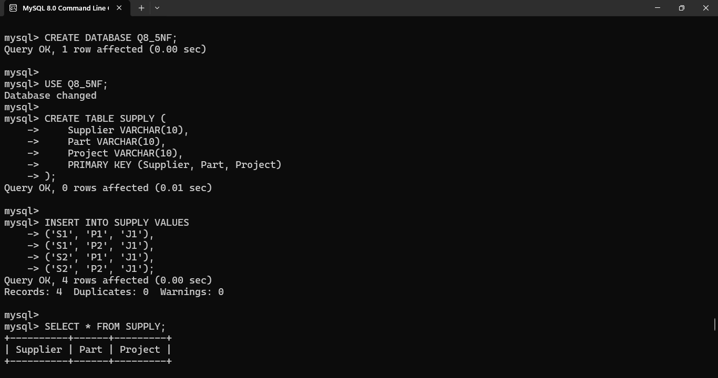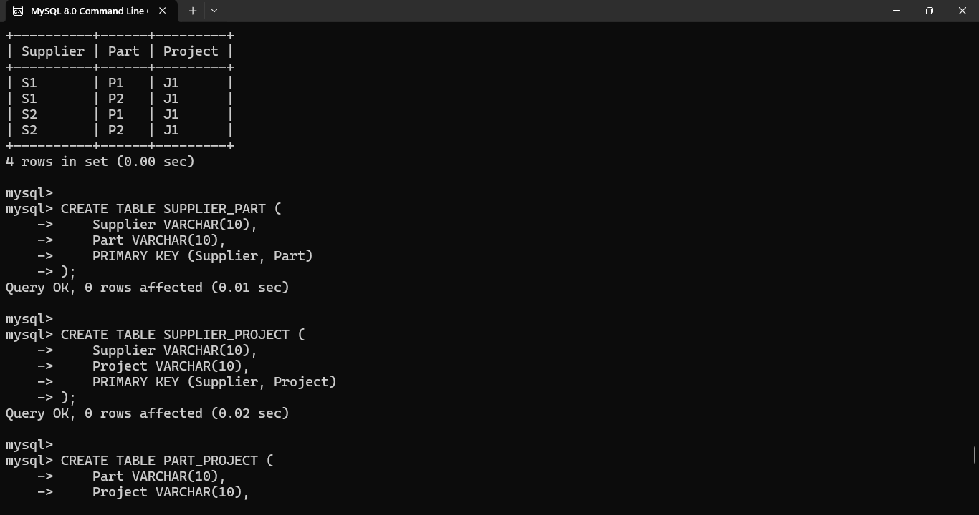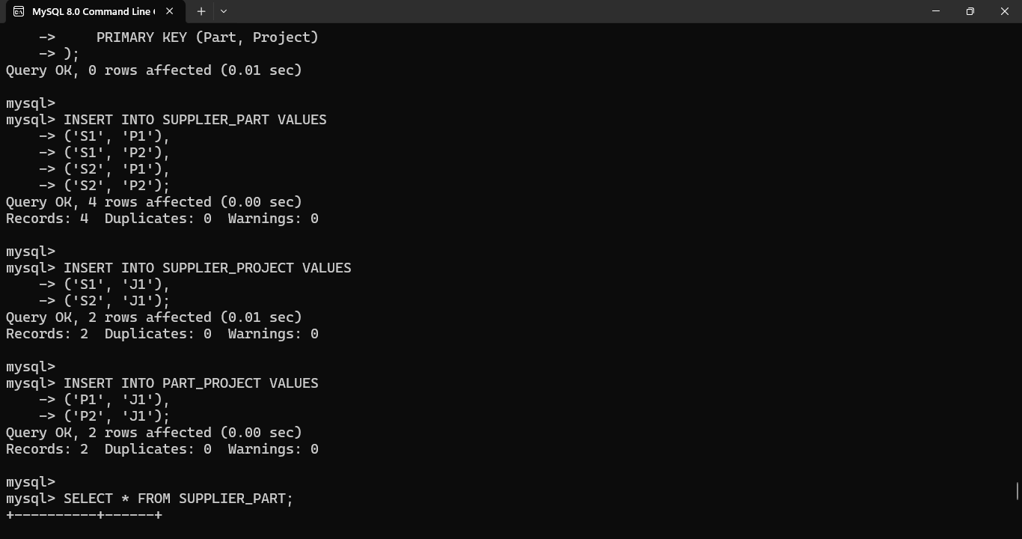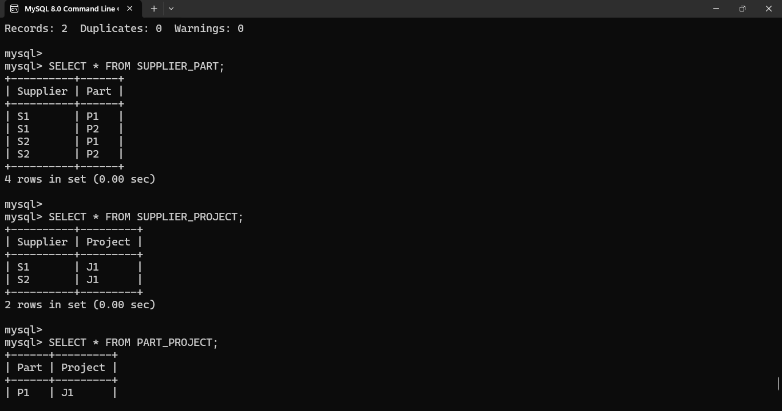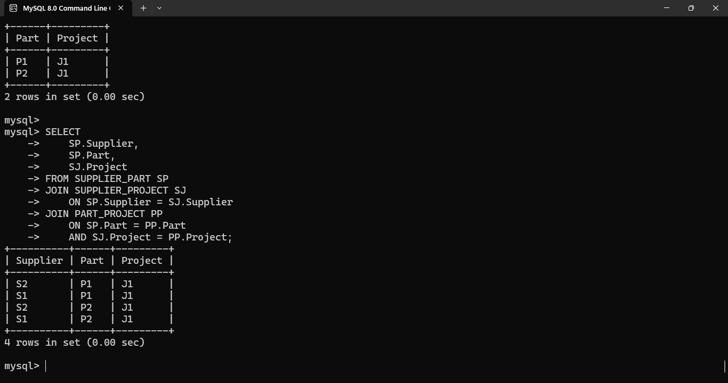
Result
The relation is decomposed into:
SP(Supplier, Part)
SJ(Supplier, Project)
PJ(Part, Project)
This decomposition reduces redundancy and represents the relation in 5NF/PJNF, provided the stated join dependency is valid for the application.

Q9. College Database – Anomalies and 3NF
Poorly Designed Relation
Consider:
COLLEGE(StudentID, StudentName, CourseID, CourseName, FacultyID, FacultyName, FacultyPhone)
Example:
StudentID | StudentName | CourseID | CourseName | FacultyID | FacultyName | FacultyPhone
S01 | Arun | C01 | DBMS | F01 | Kumar | 9876543210
S02 | Ravi | C01 | DBMS | F01 | Kumar | 9876543210
S03 | Kiran | C02 | Java | F02 | Raj | 9876543211
Functional Dependencies
Assume:
StudentID → StudentName
CourseID → CourseName, FacultyID
FacultyID → FacultyName, FacultyPhone
The candidate key is:
StudentID, CourseID
because a student can register for multiple courses.
Anomalies
1. Insertion Anomaly
Suppose a new course is introduced but no student has registered yet.
We cannot store the course information without providing a StudentID.
Therefore, insertion of course information becomes difficult.
2. Update Anomaly
If faculty F01 changes their phone number, the phone number must be updated in every student-course record.
If one record is not updated, inconsistent data occurs.
3. Deletion Anomaly
If the only student enrolled in a particular course is deleted, information about that course and its faculty may also be lost.
Step 1 – Decompose Student Information
Create:
STUDENT(StudentID, StudentName)
Step 2 – Decompose Course Information
Create:
COURSE(CourseID, CourseName, FacultyID)
Step 3 – Decompose Faculty Information
Create:
FACULTY(FacultyID, FacultyName, FacultyPhone)
Step 4 – Enrollment Relation
Create:
ENROLLMENT(StudentID, CourseID)
Final 3NF Schema
STUDENT(StudentID, StudentName)
COURSE(CourseID, CourseName, FacultyID)
FACULTY(FacultyID, FacultyName, FacultyPhone)
ENROLLMENT(StudentID, CourseID)
Keys
Relation | Primary Key
STUDENT | StudentID
COURSE | CourseID
FACULTY | FacultyID
ENROLLMENT | StudentID, CourseID
Foreign Keys
- COURSE.FacultyID → FACULTY.FacultyID
- ENROLLMENT.StudentID → STUDENT.StudentID
- ENROLLMENT.CourseID → COURSE.CourseID

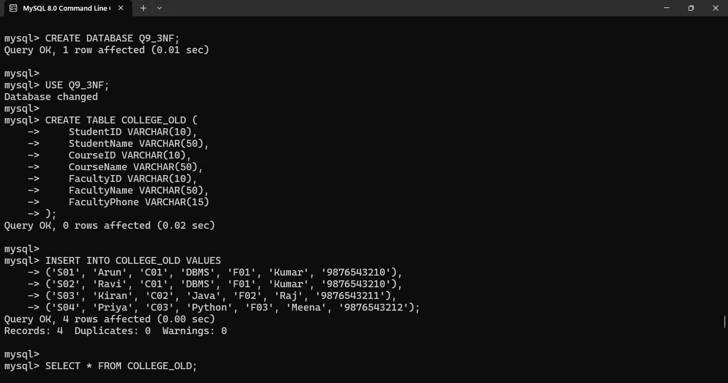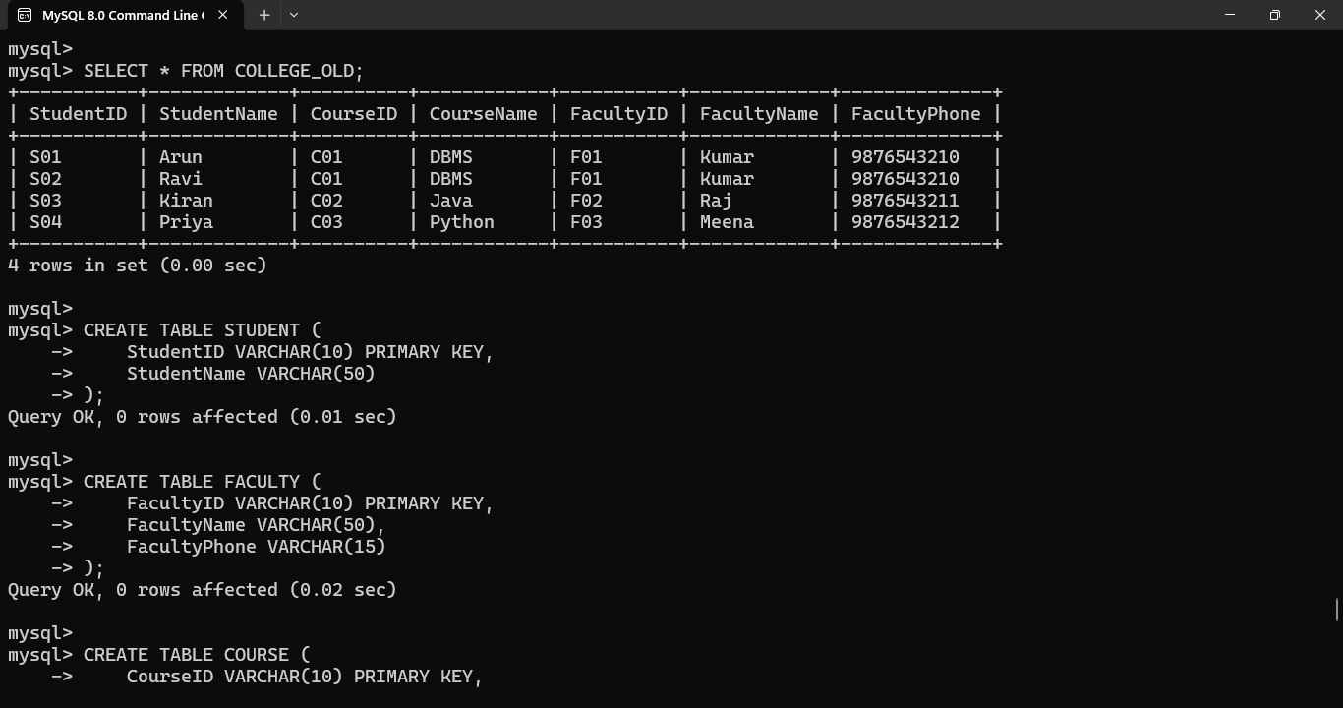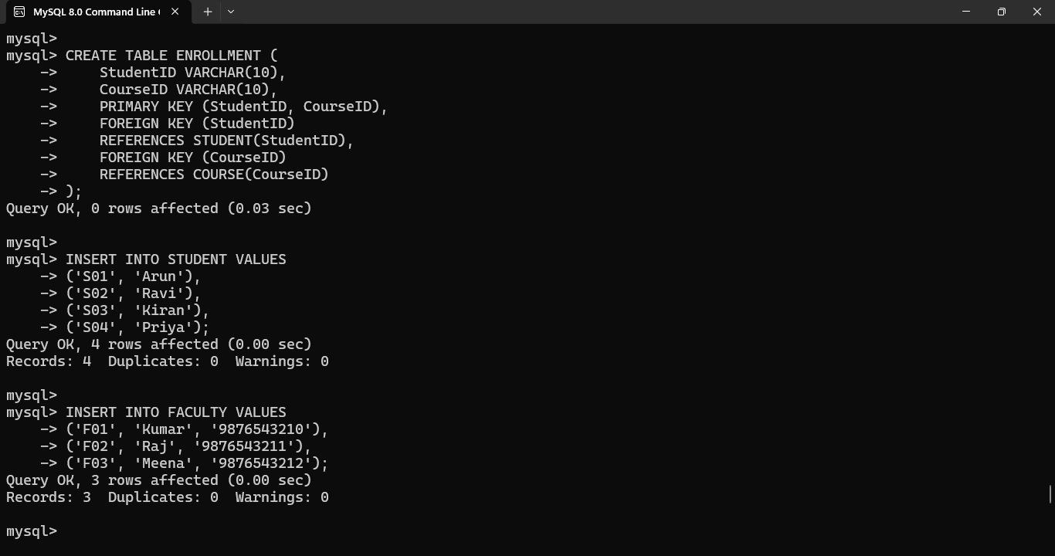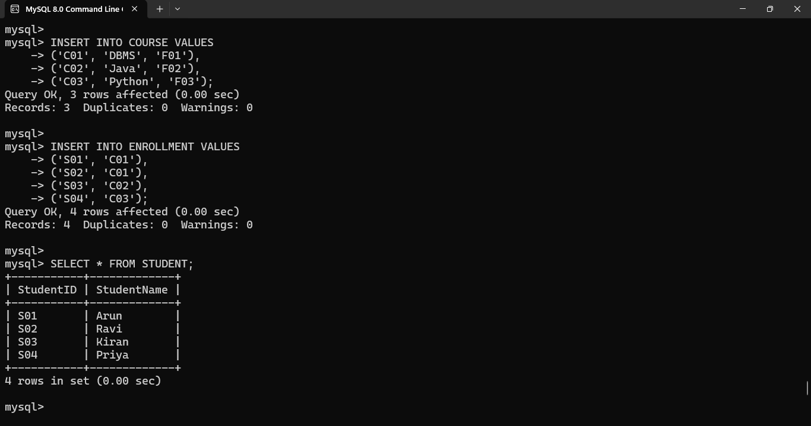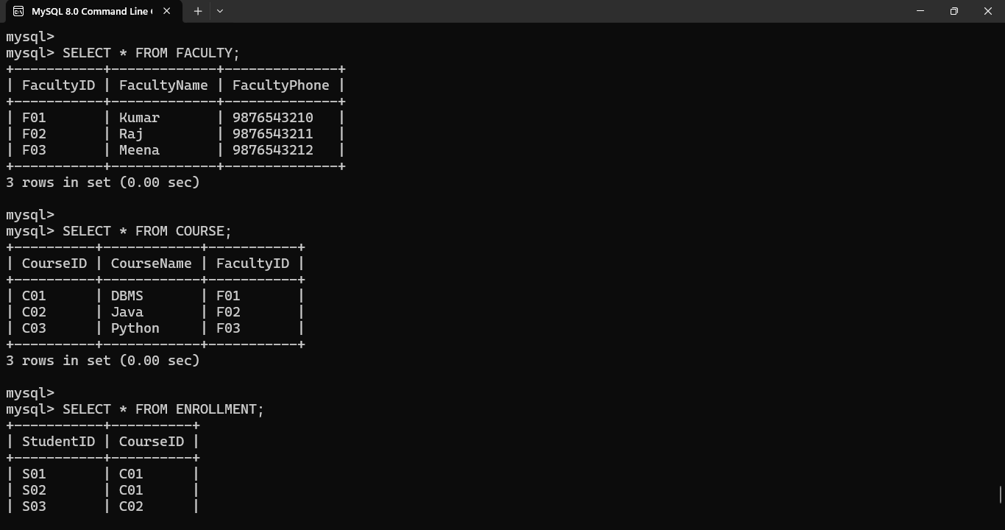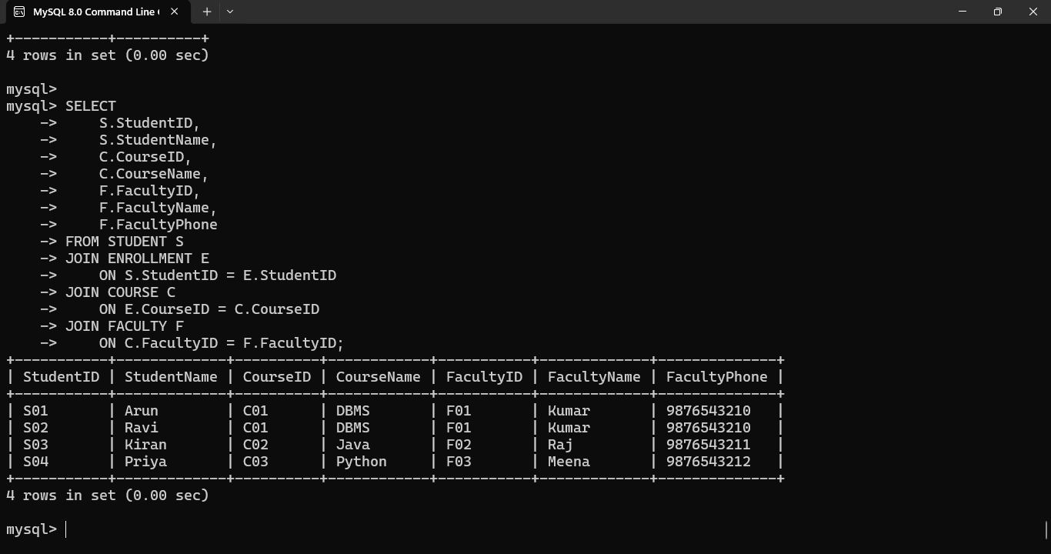
Result
The poorly designed college database has insertion, deletion, and update anomalies. After decomposition into STUDENT, COURSE, FACULTY, and ENROLLMENT, transitive dependencies are removed and the database satisfies 3NF.

Q10. Attribute Closure and Candidate Keys
Given Relation
Consider:
R(A, B, C, D, E)
Functional Dependencies:
A → B
B → C
CD → E
E → A
We need to compute attribute closures and identify candidate keys.

Step 1 – Compute A+
Start with:
A+ = {A}
Using:
A → B
we get:
{A,B}
Using:
B → C
we get:
{A,B,C}
We cannot obtain D.
Therefore:
A+ = {A,B,C}
A is not a candidate key.

Step 2 – Compute D+
Start:
D+ = {D}
There is no dependency beginning with D.
Therefore:
D+ = {D}
D is not a candidate key.

Step 3 – Compute CD+
Start:
CD+ = {C,D}
Using:
CD → E
we get:
{C,D,E}
Using:
E → A
we get:
{A,C,D,E}
Using:
A → B
we get:
{A,B,C,D,E}
Therefore:
CD+ = {A,B,C,D,E}
Hence:
CD is a candidate key.

Step 4 – Compute DE+
Start:
DE+ = {D,E}
Using:
E → A
we get:
{D,E,A}
Using:
A → B
we get:
{D,E,A,B}
Using:
B → C
we get:
{A,B,C,D,E}
Therefore:
DE+ = {A,B,C,D,E}
Hence:
DE is a candidate key.

Candidate Keys
The candidate keys are:
{C,D}
and
{D,E}
Verification of Minimality
For CD:
- C+ does not contain all attributes.
- D+ does not contain all attributes.
Therefore CD is minimal.
For DE:
- D+ does not contain all attributes.
- E+ = {E,A,B,C}, which does not contain D.
Therefore DE is minimal.
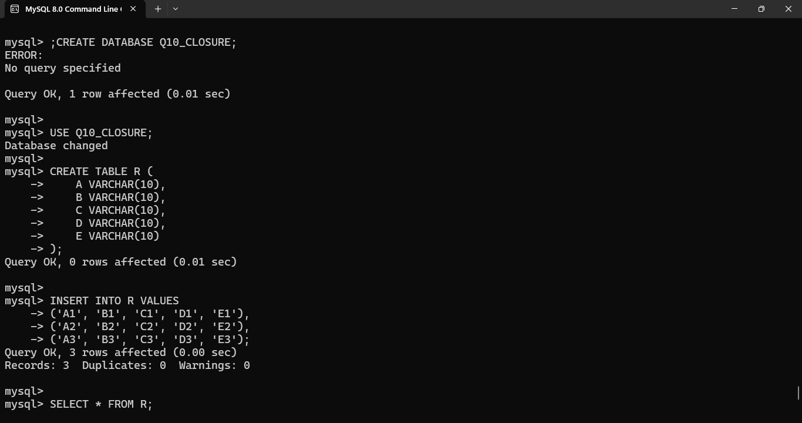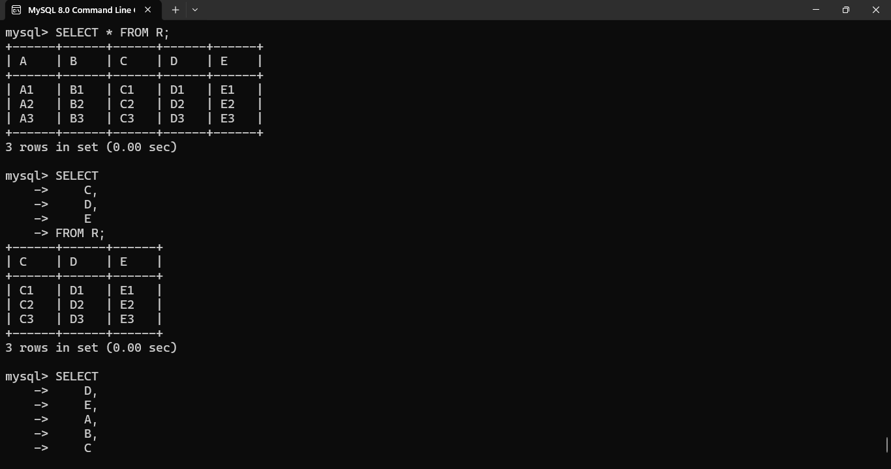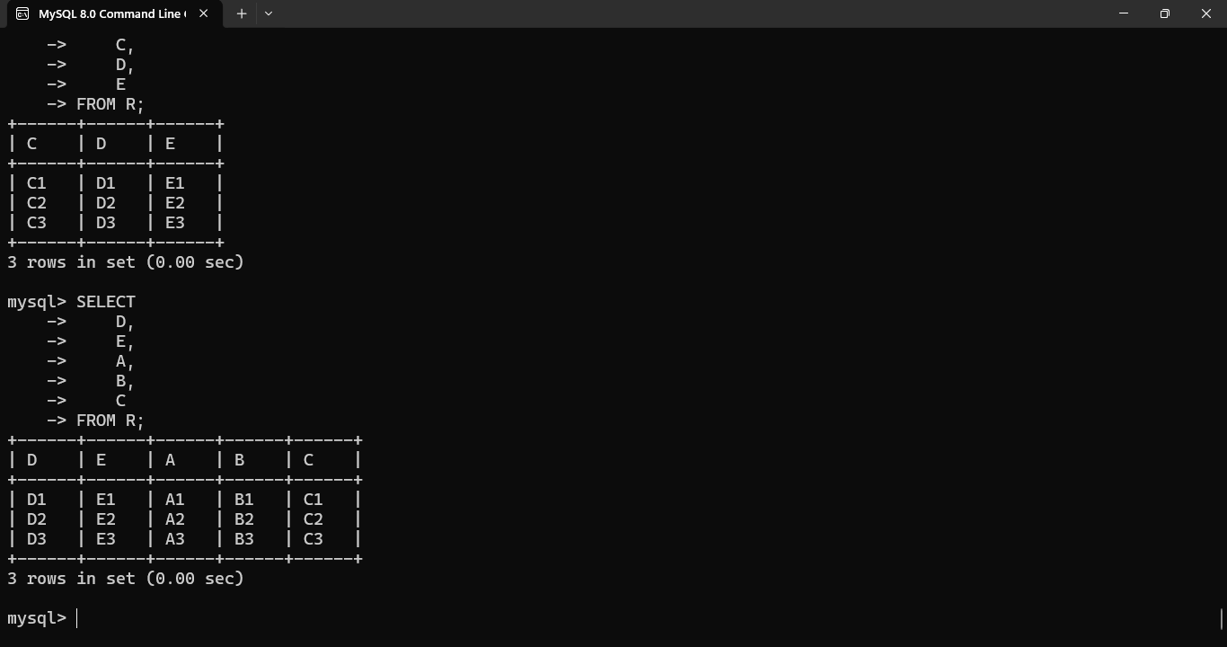
Final Result
Attribute Set | Closure | Candidate Key?
A | A, B, C | No
D | D | No
CD | A, B, C, D, E | Yes
DE | A, B, C, D, E | Yes
Therefore, the candidate keys are:
CD and DE

